Attention-Driven Deep Neural Top-K Feature Selection with Machine Learning Classifier for Scalable Android Malware Detection
Abstract
The exponential growth of digital services and smart connectivity is driving critical malware attacks on computer systems, Internet of Things (IoT)-driven models, and Android smartphones. Anti-malware software is a significant part of protecting system resources, sensitive data, and information in response to emerging malware threats. Conventional malware detection systems cannot proficiently recognize new and unknown malware variants due to advanced evasion strategies. Recently, machine learning (ML)-driven malware detection systems are developed to enhance detection precision and robustness. This study presents a Multi-Head Self-Attention Driven Feature Selection Framework for Robust Android Malware Detection (MHSAFS-RAMD). The primary objective of the proposed MHSAFS-RAMD model is to model attention based deep neural network as a feature selection approach which rank features based on its importance and generate reduced feature subset. A baseline model is constructed using XGBoost trained on the complete feature space to establish reference performance. To address the challenges of high dimensionality and redundant features, an attention-based feature selection model is introduced. In this stage, a multi-head self-attention network is used to automatically learn feature importance. The selected feature subset is further applied to the XGBoost classifier for final malware detection. By integrating attention-based selection with gradient boosting classification, the proposed model enhances detection efficiency, reduces computational complexity, and mitigates overfitting. The comparative analysis demonstrates that the proposed model achieves improved classification performance over other techniques with maximum accuracy of 99.98% and 99.99% on CICMalDroid 2020 and AndroMD datasets, respectively.
Keywords: Android Malware, Machine Learning, XGBoost, Multi-Head-Self-Attention, Feature Selection, Malware Detection
1. Introduction
Mobile devices have become increasingly significant in human life, resulting in an increase in usage. The Android operating system (OS) is the most widely utilized OS on mobile devices. It is an openly accessible source, Linux-based mobile platform commonly employed in smartphones and IoT devices. The transparent nature and massive client base make it as a primary target for malware attacks [1]. Although attacks can be performed employing several methods, the most common approach involves the attacker installing an Android application on the targeted device [2]. It covers malicious code; when opened, it grants attackers access to the user's device, allowing them to steal network and device data to perform further malicious actions. In the modern digital environment, malware is progressively being created with an advanced model that enables it to circumvent conventional classification models efficiently [3]. Even though the signature-driven approach of malware detection remained widespread, its restrictions became apparent over time. Attackers such as freelance hackers and commercial entities are using sophisticated code masking and evasion models for creating novel, robust varieties of malware that could evade traditional recognition methods [4]. As these conventional approaches achieve their functional limitation, there is an urgent necessity for exploring strong, more adaptive alternatives [5]. Machine learning (ML) is an effective tool for malware classification and recognition, providing benefits relative to conventional models.
Deep learning (DL) is a learning procedure that addresses feature representation through deep neural networks (DNNs) [6]. To learn the hierarchical representation of several features, a DL model could automatically attain intricate patterns and regularity from a group of information, displaying robust benefits in processing higher-dimensional data [7]. Feature selection (FS) is a subdivision of features to keep significant features and discard unrelated ones. As a data pre-processing technique, FS has a significant role in decreasing the dimensionality curse and enhancing the performance of the model [8]. By achieving higher precision of DL methods, experts tend to gather data and features as long as possible. Nevertheless, as database dimensions increase, the curse of dimensionality becomes more serious. Higher-dimensional data limits techniques with the overfitting risks and creates a database with noisy features or redundant ones that can decrease the model performance [9]. Features and data determine the upper limit of ML performance, though models and algorithms are designed to approach that bound. Hence, FS impacts the execution of the DL technique directly [10]. The proper number of features could offer more data and support the method best capture the complex framework and data patterns.
The most commonly utilized FS models are based on assessing the relations among the target variable and the candidate explanatory variables employing a statistical approach, preserving those with the strongest relationships [11]. The offered FS approach could be quick and efficient, but it has its weaker and stronger points. Furthermore, the selection of statistical determinants relies on the data type of both the output and input variables. The presence of extremely correlated measures is mostly challenging for each model. Novel alternatives are highly desirable, anyway, for confirming and consolidating the outcomes attained with conventional approaches. Due to its relevance and complexity of FS, the present work proposes an innovative model that contains the capability of a DL model [12].
1.1. Key Contributions of this Work
For addressing the challenges of high-dimensional and redundant feature spaces in Android malware classification, this paper proposes a novel Multi-Head Self-Attention Driven Feature Selection Framework for Robust Android Malware Detection (MHSAFS-RAMD). The proposed model aims to precisely detect malicious Android applications via attention based deep neural network as a feature selection approach. The proposed model follows a multi-faceted approach encompassing comprehensive data preprocessing, baseline modeling, attention-based feature selection, and gradient boosting-driven classification. The efficiency of the proposed MHSAFS-RAMD method is assessed using two benchmark datasets across diverse performance metrics. The key contributions of this research include the following:
- Establish a strong baseline model utilizing XGBoost trained on the full feature space to offer a fair reference for assessing the efficiency of the proposed feature selection strategy.
- Propose a multi-head self-attention (MHSA) network as a feature selection technique instead of a classifier. Unlike existing studies that use multi-head attention primarily for classification, the proposed model utilizes attention weights for automatically learning feature importance and selecting a discriminative feature subset.
- Integrate the attention-selected feature subset with the baseline classifier to improve detection accuracy while decreasing computational complexity, minimizing redundancy, and mitigating overfitting.
- Conduct extensive experimental validation on CICMalDroid 2020 and AndroMD datasets under various measures, signifying that the proposed MHSAFS-RAMD model achieves better classification performance compared to existing methods.
2. Review of Android Malware Detection Methods
Some existing techniques related to Android malware detection systems are discussed in this section. Kirubavathi et al. [13] proposed a crucial task for real-world deployment; novel ransomware variations constantly falsify their signatures and vary network traffic patterns to avoid detection. The presented a strong ensemble-driven ML structure for early detection of Android ransomware employing network traffic metadata. Moreover, explainable artificial intelligence (XAI) approaches like SHAP and LIME are used to improve interpretability and analyst trust. In this detection, the significance of online learning lies in the capability of adapting to evolving threat patterns in the real world. Poornima and Mahalakshmi [14] introduced an innovative malware attack recognition in Android employing a deep belief network that precisely identifies and reduces the malware threats and improves the device's security. In the feature extractor, the information is identified into two kinds: signature-driven data and behaviour-driven data. The next stage is where the malicious and benign data are identified by employing a DBN model. Therefore, the identified malicious data is changed into a detection record for additional processing. Musa and Younis [15] proposed the formation of malware detection that depends on DL and optimizer models. This model a more sophisticated malware detection method, which uses DL techniques and the Grey Wolf Optimier (GWO) model for selecting vital features. Utilizing various techniques is tested: LSTM and CNN techniques with GWO.
Mudunuru and Rani [16] presented a hybrid learning structure for Android malware detection employing grayscale imaging created entirely from DEX bytecode segmentation. Many deep feature extraction that depends transfer learning structure are used for obtaining higher-level semantical representations from DEX imaging. In contrast, handcrafted descriptions include GLCM, ORB, HOG, SIFT, and LBP, which take complementary gradient and textual features. The fused feature representations are assessed employing various ML classification. Nethala et al. [17] suggested an innovative malware detection method using an ensemble of CNNs for improved classifier precision. The model integrates a multi-stage procedure, beginning with the extraction and pre-processing of APK files. The extraction of byte information is changed into one-dimensional vectors and redesigned into two-dimensional grayscale imaging, allowing effective feature representation across CNNs. Vijaya et al. [18] introduced a robust structure for malware detection on the Android mobile platform by integrating smart identification system. It includes integrating the XGBoost classification, which excels in handling huge databases and has a lower probability of overfitting, together with other famous classification methods. The model is based on the utilization of static features, which are gathered from the Android application package that involves the access request and the calls made to the API. The classifiers of the application depend on whether it is malicious or harmless.
In [19], the authors proposed AI-driven methods are progressively utilized for protecting models from cyber-attacks. It concentrated on the use of ChatGPT, an effective LLM, within cybersecurity, particularly for malware recognition. This appraises ChatGPT’s potential as a new tool in mitigating cyber-attacks, investigating the procedure of fine-graining ChatGPT, its execution, and its restrictions in the malware detection challenge. By decreasing the time and effort essential for generating an AI-driven malware detection method, easing the process of developing. Wasif et al. [20] developed a system to convert the network traffic data into images that are then analysed employing DL techniques. The presented hybrid technique that effortlessly combines Vision Transformers (ViT) and CNN for classifying malicious activity. Especially, the model investigates different image resolutions, outcome that a 180×180 resolution optimized detection precision without compromising process speed. Table 1 presents existing models for Android malware detection, including their objectives, employed models, key findings, and limitations.
Table 1 Related works on android malware classification methods
References | Years | Objectives | Models | Key Findings | Limitations
Kirubavathi et al. [13] | 2026 | Detect Android ransomware in real-time using network traffic metadata. | ML models | Accuracy of 98.84 %. | Framework tested only on network metadata, not app-level features.
Poornima and Mahalakshmi [14] | 2024 | Classify data into signature-based and behavior-based features. | ANN, LSTM, and GAN models. | Accuracy of 99.83 % | Sequence conversion may oversimplify some behavioral patterns.
Musa and Younis [15] | 2026 | Enhance computational efficiency via optimized feature selection. | CNN and LSTM techniques. | Accuracy of 93 % | Real-time deployment may face latency on mobile or resource-constrained devices.
Mudunuru and Rani [16] | 2026 | Fuse deep and handcrafted features for richer representations. | SVM, KNN, and RF techniques. | Accuracy of 94.40%. | Image transformation may lose some behavioral information of malware.
Nethala et al. [17] | 2025 | Provide a scalable framework suitable for large-scale Android apps. | CNN model | Accuracy of 98.65%. | Detection focuses on identification, not prevention or mitigation,
Vijaya et al. [18] | 2026 | Establish a new benchmark for Android malware classification. | Naive Bayes, KNN, Decision Tree, and LR methods | Accuracy of 100%. | Does not incorporate network traffic or behavioral analysis.
Nelson et al. [19] | 2025 | Utilize ChatGPT for AI-based malware detection on Android systems. | CNN, MLP, SVM, KNN and RF models. | Accuracy of 99%. | Evaluation limited to structured datasets; real-world generalization is uncertain.
Wasif et al. [20] | 2025 | Simplify feature extraction compared to traditional methods. | ViT and CNN techniques | Accuracy of 99.61%. | Hybrid model requires careful tuning of hyperparameters for best performance.

Though several approaches related to Android malware classification exists, they mainly focused either on single ML or DL model which has absence of interpretability and effectual feature prioritization. Several works make use of static or dynamic features without sufficiently resolving high-dimensional and repetitive feature space, resulting in maximum computation complexity with less scalability for real time deployment. Moreover, existing feature selection approaches does not effectively derive contextual and dependency-aware relationships among features, diminishing their performance on classifying evolving malware patterns. Therefore, a critical gap exists in presenting a scalable, attention-guided Top-K feature selection model which decreases dimensionality, and enhances malware detection efficiency in dynamic and large-scale Android environment.
3. Research Methodology
This research implements a structured pipeline for identifying and classifying Android malware. Fig. 1 showcases the end-to-end architecture of the MHSAFS-RAMD approach for Android malware detection. In this study, two benchmark datasets, CICMalDroid 2020 and AndroMD, are utilized for developing and validating the model under a consistent experimental setup. The step-by-step process involved in the proposed model are listed as follows.
- Step 1: Preprocessing
Initially, the dataset undergoes a preprocessing stage. This includes data cleaning, label encoding, missing value handling, feature scaling, and data splitting into training and testing sets for ensuring reliable and unbiased evaluation.

- Step 2: Model Selection
Once preprocessing is done, a baseline model is developed using XGBoost trained on the full feature set to establish a reference performance level.

- Step 3: DL based Attribute Selection
An MHSA network is used to automatically learn feature importance scores through capturing complex interactions among features. Depending on these learned attention weights, the most relevant attributes are selected to form a better feature subset.

- Step 4: FS based Classification
The selected attributes are then passed into the XGBoost classifier for final malware classification. Combining attention-based selection with gradient boosting improves detection, decreases overfitting, and significantly lowers computational costs.
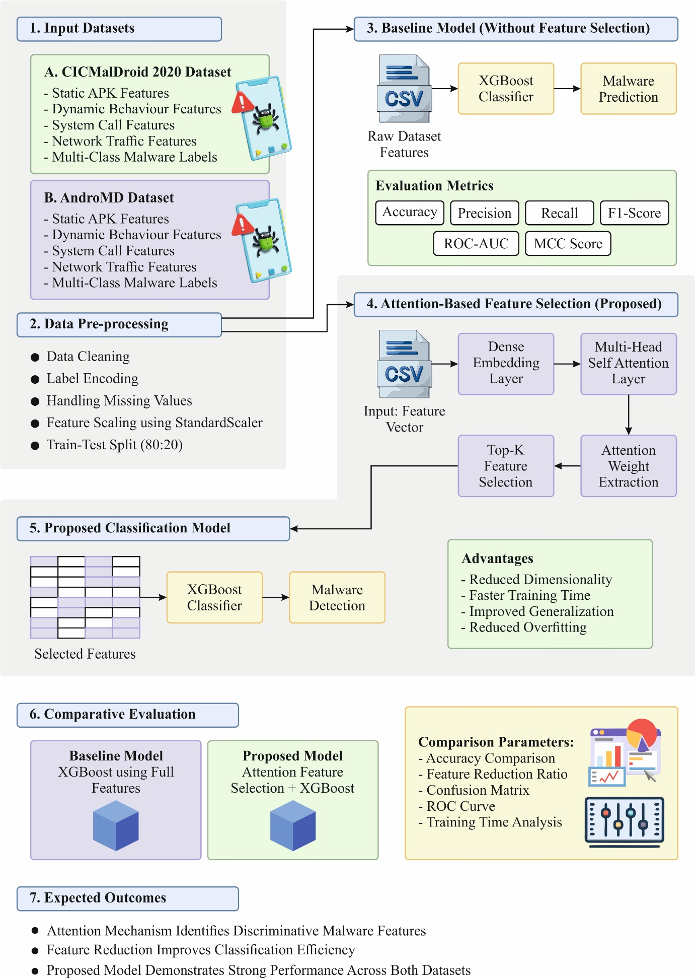
Fig. 1. End-to-end architecture of the MHSAFS-RAMD model

3.1. Data Used
The performance validation of the proposed model is inspected using two datasets such as CICMalDroid 2020 Dataset [21] and AndroMD Dataset [22]. The following is a brief description of the datasets.
CICMalDroid 2020 Dataset: The dataset is large, comprising over 11,526 Android samples; recent, including advanced Android samples gathered up to 2018; diverse, spanning five different classes: Adware, Banking malware, SMS malware, Riskware, and Benign; and comprehensive, containing the most complete set of captured static and dynamic features compared with publicly available datasets. Fig. 2 denotes the class distribution.
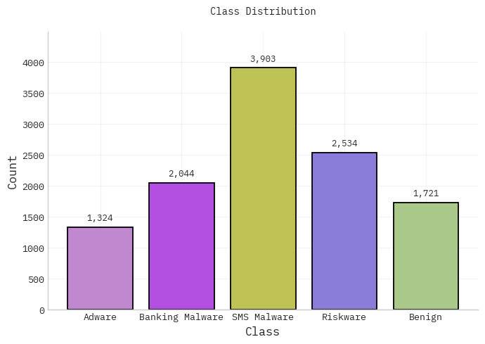
Fig. 2. Class distribution with CICMalDroid data
AndroMD Dataset (Latest): This dataset contains 34652 Android applications (26,827 benign, 7,825 malicious) collected from AndroZoo and VirusShare from 2010-2023. It comprises three subsets: KeyCount (frequency of suspicious code tokens), ZeroOne (binary presence of malicious indicators), and MNF (permissions from AndroidManifest.xml). Automated disassembly and static analysis were employed to extract features, focusing on behavioral patterns such as network connectivity, data access, encryption routines, and restricted privileges. Developed for ML, the dataset assists effective malware detection and is a key component of the AndroMD framework’s classification and live detection abilities. Fig. 3 denotes the class distribution.
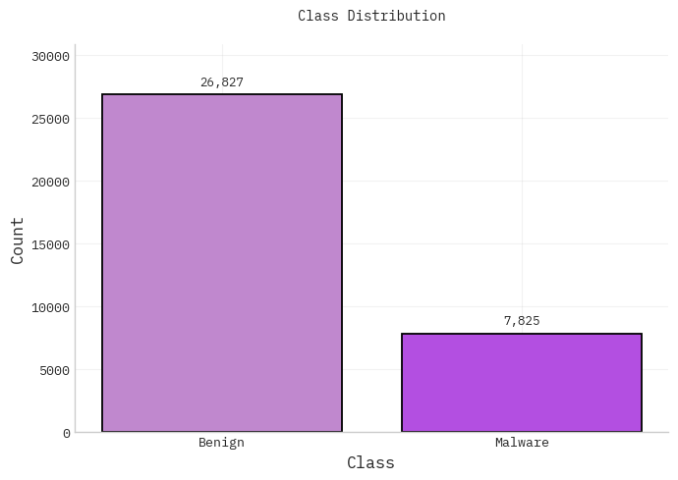
Fig. 3. Class distribution with AndroMD data
3.2. Data Preparation and Preprocessing
The preprocessing phase comprised the following tasks, which were applied separately to each dataset using the same steps: data cleaning, label encoding, missing value handling, feature scaling, and data splitting [23].
Data Cleaning: Raw databases frequently comprise redundant entries, irregularities, or formatting inconsistencies, which can impact the dependability of developed methods. Thus, a data cleaning process is led to improve the quality of data and ensure consistency throughout the database. The procedure included classifying and modifying structural irregularities, eliminating redundant reports, and assuring similar representation of feature parameters. These steps enhanced data integrity and offered a consistent foundation to follows pre-processing and modeling phases.
Label Encoding: It is a pre-processing model employed for converting the class labels into numerical values. All unique classes are allocated a particular value of an integer, allowing the ML method to analyze non-numeric labels efficiently.
Here, $y$ denotes the class labels. The encoder maps all unique class $c$ to an associated value of integer $i$:
$f(c)=i, let i∈\{0,1, …, n-1\} (1)$
where $n$ represents the overall unique classes, and $f(c)$ denotes the map function.
Label Encoding transforms benign and malware labels into numerical representation, facilitating the training of ML models compatibility. This is computationally effective and simplifies the direct incorporation of categorical class data into the Android malware detection structure.
Handling Missing Values: Mean imputation is used for handling missing values inside the database. In this method, missing values are replaced employing the arithmetic mean calculated from the accessible observations of the corresponding feature. In mathematics, the imputed value is represented as:
$${\hat{X}}_{i}=\frac{1}{∣V∣}\sum_{v∈V}{X_{v}} (2)$$
Now, $V$ denotes the set of accessible observations for the provided feature.
Mean imputation is efficient when the percentage of missing values is comparatively lower and when feature variance is reasonable. Because of the computational efficiency and straightforward implementation, it acts as a baseline imputation approach in this research.
Feature Scaling using StandardScaler: It is a pre-processing method utilized for normalizing features to remove the mean and scale to unit alteration. This assures that the attributes have a standard deviation of one and a mean of zero, creating the data suitable for ML models sensitive to the magnitude of the feature. The standard deviation of a feature $x$ is calculated as:
$z=\frac{x-μ}{σ} (3)$
In this formula, $x$ represents a realistic feature value; $μ$ and $σ$ implies the mean and standard deviation of the features. StandardScaler enhances the technique to ensure that features are comparably scaled, thus enabling ML methods to converge more quickly and avoid biases because of differing magnitudes of features. In addition, it improves numerical consistency and reduces problems arising from exceptional values.
3.3. Baseline Classifier Model
A baseline model is created using XGBoost trained on the complete feature space for establishing reference performance. XGBoost is an ML technique that is extensively employed for detecting Android malware [24]. The method has the benefit of lower computation time and higher classifier precision. Assume a provided dataset $D,$
$D=\left\{\left(x_{i},y_{i}\right): i=1,2⋯, n,x_{i}∈R_{i},y_{i}∈R\right\} (4)$
Here, $i$signifies the number of instances and $m$ represents the count of features. The method is a function that could be utilized for estimating the response variable ${\hat{y}}_{i}$ from the input variable $x_{i}$, and for $K$( $K=1,2,…,K$) number of iterations as in Eq. (5).
${\hat{y}}_{i}=\sum_{k=1}^{k}{f_{k}}(x_{i})={\hat{y}}_{i}^{(K-1)}+f_{k}(x_{i}) (5)$
Here, $f_{k}(x_{i})$ represents the tree method attained after the k‐th iteration.
The primary process of XGBoost is represented in Eqs. (6) and (7):
$L=\sum_{i=1}^{n}{l}\left(y_{i)}\hat{y}\right)+\sum_{k=1}^{k}{Ω}\left(f_{k}\right) (6)$
$Ω(f_{k})=γT+\frac{1}{2}λ||ω{\left| \right|}^{2} (7)$
Let $n$ denote the number of instances utilized for constructing the $k$-th tree. To enhance the classifiers' outcomes, $l(y_{i},{\hat{y}}_{i})$ denotes the training loss, in which $y_{i}$ is the true label, and ${\hat{y}}_{i}$ is the predicted label, which must be reduced. where, $f_{k}$ denotes an independent tree at $k$-th iterations that divides the space of feature $R^{m}$into $T$-disjoint areas or leaves $\left\{R_{ik}\}_{i=1}^{T}\right.$with weights $w_{ik}$( $w∈R^{T}$). As defined in Eqs. (8) and (9), the $k$-th function of base learner $n$aggregates the weightings assigned to its respective leaves.
$f_{k}(x_{i})=η\sum_{i=1}^{T}{w_{ik}}I (8)$
$I=\{i|q(x_{i})=j\} (9)$
Now, $η∈(0,1$] represents the parameter that restrains the rate of learning and controls the overfitting; $q(x_{i})$ denotes the leaf node assigned to the sample.
The sample set $I$of leaf node $j$ decides the model difficulty. The variables $λ$ and $γ$ in Eq. (7) are regularized parameters that restrain tree difficulty and avoid overfitting. Fig. 4 depicts the architecture of XGBoost.
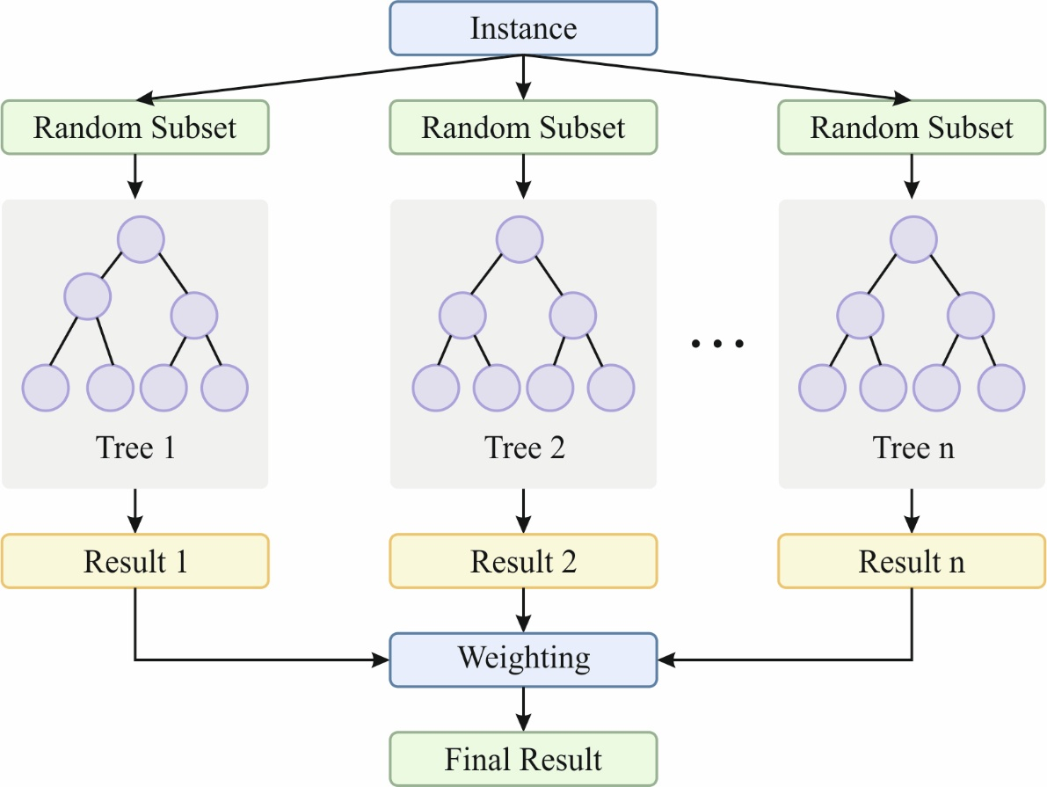
Fig. 4. Architecture of XGBoost
3.4. Proposed Attention Deep Learning Model for Feature Selection
In the proposed model, a Multi-Head Self-Attention (MHSA) network learns contextual relationships between attributes. Compared to the conventional method, which treats features separately, attention evaluates all features in relation to others. It is critical in malware detection, where some feature integration can specify malicious activity even when individual characteristics seem benign. The attention mechanism works by:
- Learning latent representations of input features
- Assessing inter-feature relevance
- Allocating adaptive significance weights
The preprocessed Android application database consists of intricate inter-feature relationships and longer-range dependencies between permissions, calls of API, and behavioral measures. Leveraging an MHSA module allows learning different data through various representation subspaces. It takes contextual dependency, enhances the global interaction of features, and allocates diverse weights to features, avoiding equal treatment of all features.
The MHSA mechanism has dual stages, each with a projection layer of dense and transformer block for extracting inter-feature dependency. All projection layers involve a linear transform passed through layer normalization (LN) to improve feature representations, though preserve inherent relations [25]. A light MHSA layer method for global interaction of features improves non-linear representation. The dual transformer blocks are weighted for capturing complete multi-scaling feature connections.
Feature transformation: This stands as a critical property in FS challenge. So, a linear projection layer is used for maintaining feature representation consistency.
$X^{'}=Linear \left(X\right)+X (10)$
In Eq (10), $X∈R^{N×D},$ here $N$ denotes the count of features and $D$ implies the dimension of the feature. Linear () signifies the projection function, and $X^{'}$ denotes the feature transformation
Light multi‐head self‐attention mechanism: The self‐attention module mostly uses the scaled dot‐product function. The attention mechanism captures input from 3 matrices: value (V), query (Q), and key (K). The outcome is a weighted amount of resemblance and value that relies on Q and K. The equations for computing Q, K, and V are provided in Eqs (11), (12), and (13).
$Q={Linear}_{Q}(X^{'}) (11)$
$K={Linear}_{K}\left(Conv\left(X^{'}\right)\right) (12)$
$V={Linear}_{V}\left(Conv\left(X^{'}\right)\right) (13)$
By using many parallel attention heads, the method takes different connections between features. It allows learning rich contextual dependency through different representation subspaces. Multi-head outputs are spliced together, after which a final projection matrix $W^{o}$ fuses the multi-space representations. At last, the final result of MHSA is derived.
$head=Attention(Q, K, V)=softmax (QK^{T}/\sqrt{d_{k}})V (14)$
$X^{''}=sMHSA=Concact[head_{1};head_{2}……head_{n}]W^{o} (15)$
In this formula, MHSA signifies the function of the MHSA module, softmax denotes the function of softmax, $d_{k}$ implies the aspect of K, and $X^{''}$ denotes the outcome of the MHSA layer.
Multi-head attention enables the method for learning several relevance patterns concurrently, with every head capturing various interactions of features. It creates attention weight distribution, which replicates the contextual significance of all features instead of classifying performance. Features are graded based on combined attention scores, and the Top-K module keeps only the most informative $K$ attributes. This method enhances efficacy, noise reduction, and highlights the most important features.
- Decreases dimensionality
- Redundant features or noise removal
- Enhances training efficacy
- Improves generalized outcomes
The $K$ value is measured directly across the analysis of validation. Unlike value of $K$are assessed for classifying the optimum trade-off between classifier outcomes and dimensional reduction. This selection approach assures that only contextual important features, as studied by the attention network, are fed to the final classification.
3.5. Reduced Feature Subset based Classification Model
The selected Top-K features are provided to the XGBoost classification for performing the final malware detection. To limit the input space to the most informative features classified across the attention module, the classification focuses on discriminating behavioral, permission-driven, and API-related features instead of irrelevant or redundant features. This method is assessed and trained under similar experimental conditions accepted for the baseline technique to ensure consistency in competitive analysis. In this phase, XGBoost makes an ensemble of decision trees in a sequential boosting manner, while all subsequent tree intended for reducing the residual errors of the past iteration. The minimized feature subdivision allows more steady gradient upgrades and declines computational load in training. Furthermore, restricting the feature space reduces the issues of overfitting generally monitored in higher-dimensional malware databases. It combined structure, integrating attention-guided feature decrease with gradient boosting classifiers, thus improving detection effectiveness while preserving strong prediction outcomes through diverse Android malware databases.
3.6. Performance Metrics
The performance of the classifier techniques is assessed, and the total prediction is measured through various measures such as Precision, Accuracy, F1-score, Recall, ROC-AUC, and MCC. The descriptions of these measures are given below:
$$Accuracy=\frac{TP+TN}{TP+TN+PN+FP} (16)$$
$$Precision=\frac{TP}{TP+FP} (17)$$
$$Recall=\frac{TP}{TP+FN} (18)$$
$$F1- Score =\frac{2×\left(Precision×Recall\right)}{Precision+Recall} (19)$$
$$AUC=\int_{0}^{1}{TPR\left(FPR\right)d\left(FPR\right)} (20)$$
Where,
$$TPR=\frac{TP}{TP+FN} (21)$$
$$FPR=\frac{FP}{FP+TN} (22)$$
$$MCC=\frac{TP×TN-FP×FN}{\sqrt{(TP+FP)(TN+FP)(TN+FN)(TP+FN)}} (23)$$
In these expressions, TP implies true positive, which is the count of original positive samples that are appropriately identified. In contrast, FP stands for false positive, which represents the percentage of negative instances inaccurately forecasted as positive. TN stands for true negative, which signifies the fraction of negative instances exactly predicted, while FN stands for false negative, which signifies the number of positive samples that are wrongly identified as negative. Moreover, the ROC-AUC metric is employed for evaluating the overall effectiveness of the proposed model across different threshold settings.
4. Experimental Validation and Discussion
In this section, the experimental evaluation of the proposed model is provided in detail on dual datasets and performance metrics. This analysis demonstrates the feasibility and applicability of the proposed model in the actual Android malware detection process.
4.1. Results Analysis on CICMalDroid 2020 Dataset
Fig. 5 shows the confusion matrices of the MHSAFS-RAMD system under the Train/Test on CICMalDroid data without feature selection (FS). The outcomes specify that the MHSAFS-RAMD technique proficiently recognizes each class.
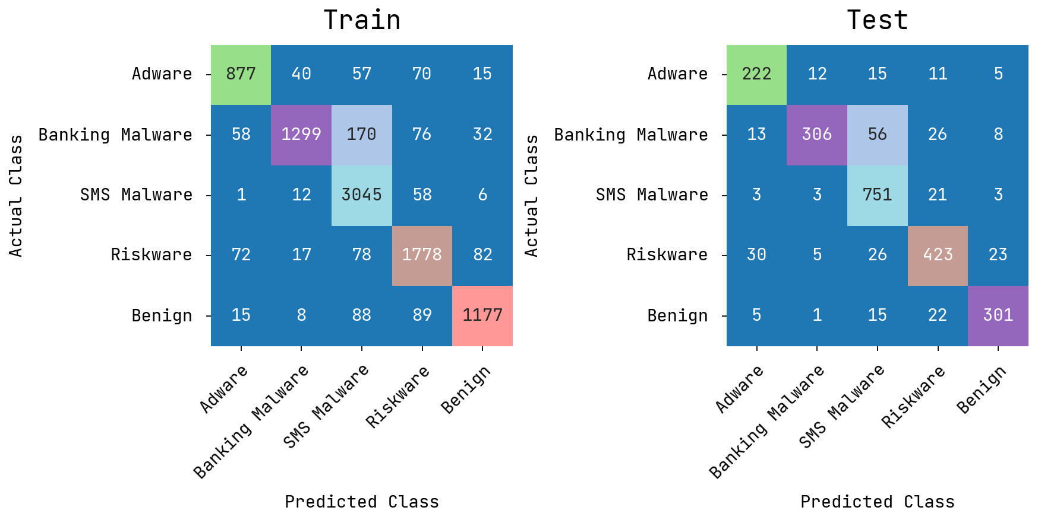
Fig. 5. Confusion matrices of the MHSAFS-RAMD method without FS under CICMalDroid data
Table 2 portrays the train and test results of MHSAFS-RAMD technique at CICMalDroid data without FS under diverse measures. Under training set, the proposed MHSAFS-RAMD system accomplishes average result with $accur_{y}$ of 88.68%, $preci_{n}$ of 88.85%, $recal_{l}$ of 86.60%, $F1_{score}$ of 87.54%, $ROC-AUC_{score}$ of 97.68%, and MCC of 85.30%. Likewise, under testing set, the proposed MHSAFS-RAMD model achieves average result with $accur_{y}$ of 86.86%, $preci_{n}$ of 86.91%, $recal_{l}$ of 85.14%, $F1_{score}$ of 85.76%, $ROC-AUC_{score}$ of 96.94%, MCC of 83.00%, correspondingly.
Table 2 Train/Test set results of the MHSAFS-RAMD method on CICMalDroid data without FS
Metrics | Training Set | Testing Set
Accuracy | 88.68 | 86.86
Precision | 88.85 | 86.91
Recall | 86.60 | 85.14
F1-Score | 87.54 | 85.76
ROC-AUC Score | 97.68 | 96.94
MCC | 85.30 | 83.00

Fig. 6 represent the number of features chosen before FS and after FS under the applied CICMalDroid dataset. The figure illustrates that the proposed model has chosen 216 features out of the total 470 features.
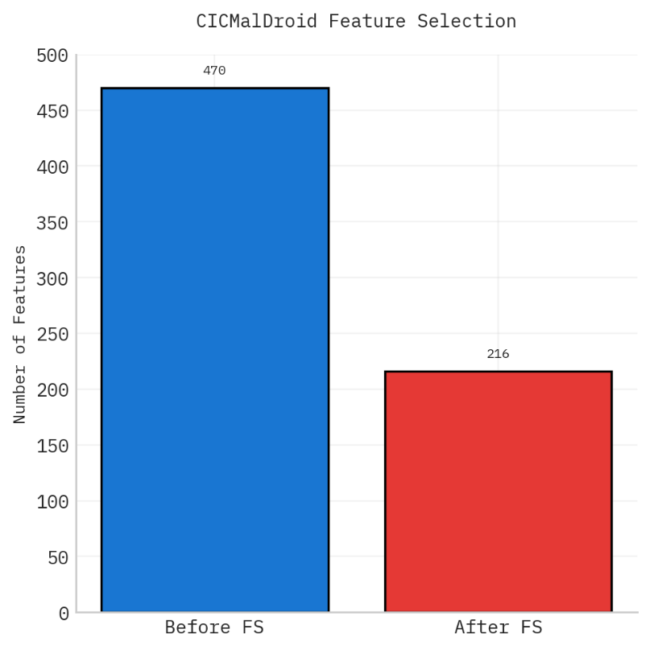
Fig. 6. Before FS and After FS under CICMalDroid data
Fig. 7 shows the confusion matrices of the MHSAFS-RAMD model under the Train/Test under CICMalDroid data with feature selection (FS). The outcomes denote that the MHSAFS-RAMD system efficaciously classifies every class.
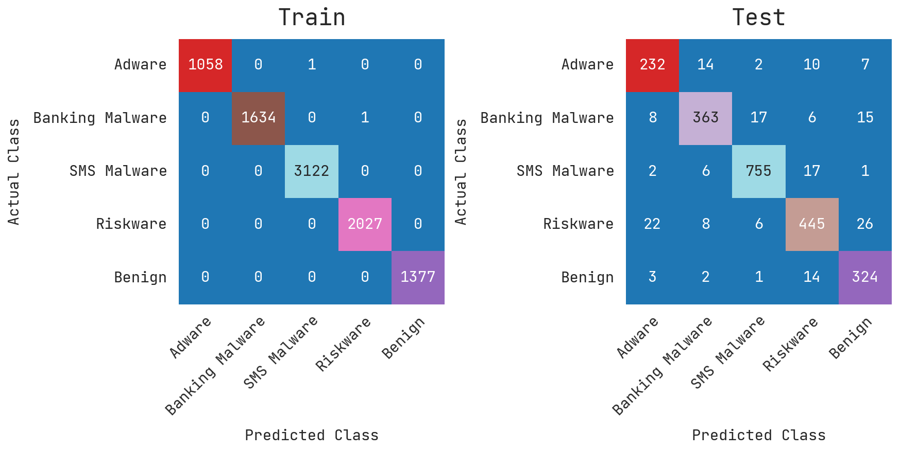
Fig. 7. Confusion matrices of the MHSAFS-RAMD method with FS under CICMalDroid data
Table 3 portrays the train and test outcome of MHSAFS-RAMD technique on CICMalDroid data with FS under various measures. Under training set, the proposed MHSAFS-RAMD technique attains average result with $accur_{y}$ of 99.98%, $preci_{n}$ of 99.98%, $recal_{l}$ of 99.97%, $F1_{score}$ of 99.98%, $ROC-AUC_{score}$ of 99.98%, MCC of 99.90%. Similarly, at testing set, the proposed MHSAFS-RAMD method obtains average result with $accur_{y}$ of 91.89%, $preci_{n}$ of 90.65%, $recal_{l}$ of 90.99%, $F1_{score}$ of 90.78%, $ROC-AUC_{score}$ of 98.13%, and MCC of 93.60%.
Table 3 Train/Test set results of the MHSAFS-RAMD method on CICMalDroid data with FS
Metrics | Training Set | Testing Set
Accuracy | 99.98 | 91.89
Precision | 99.98 | 90.65
Recall | 99.97 | 90.99
F1-Score | 99.98 | 90.78
ROC-AUC Score | 99.98 | 98.13
MCC | 99.90 | 93.60

Fig. 8 displays the PR/ROC curves of MHSAFS-RAMD model on training and testing stages with CICMalDroid data. Figs. 8a-8c reveals the PR investigation of the MHSAFS-RAMD system. The results indicated that the MHSAFS-RAMD model improves PR values. Besides, it is noteworthy that the MHSAFS-RAMD model achieves superior PR values on each class. Lastly, Figs. 8b-8d depicts the ROC analysis of the MHSAFS-RAMD technique. The figure defined that the MHSAFS-RAMD system improves ROC values. In addition, it is noteworthy that the MHSAFS-RAMD model accomplishes excellent ROC values on every class.
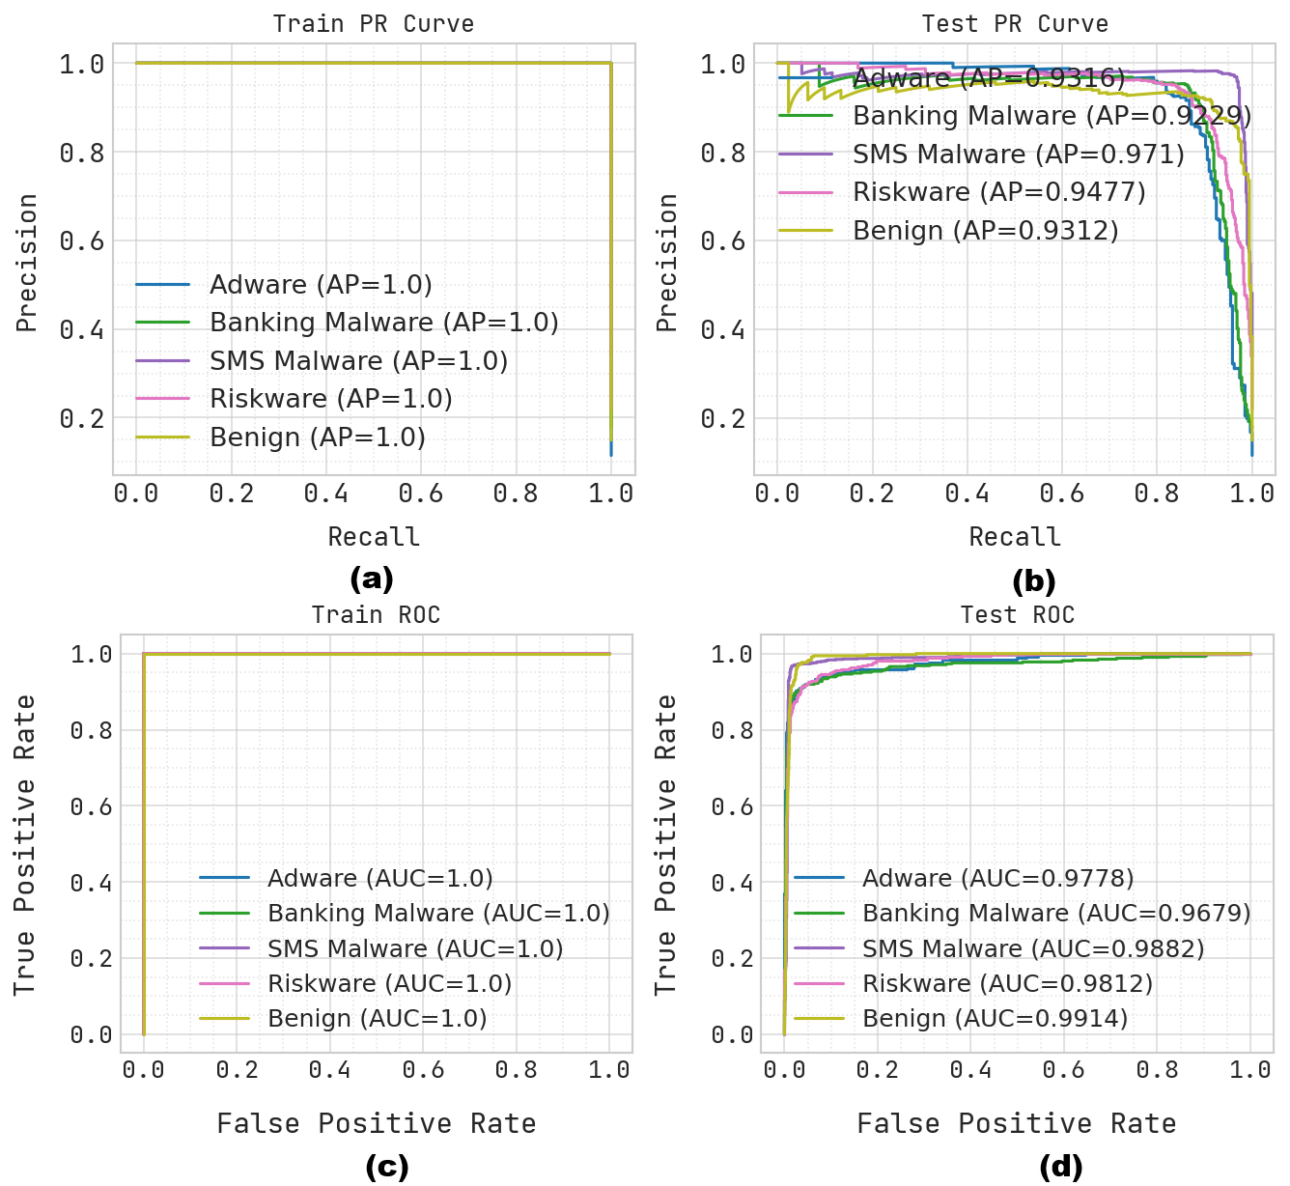
Fig. 8. PR/ROC curve of the MHSAFS-RAMD method with (a, c) Training and (b, d) Testing phases
To prove the better performance of the MHSAFS-RAMD technique on the CICMalDroid data, a detailed comparative analysis is given in Table 4 and Fig. 9 [26-28]. The results highlighted that the SVM model has shown lower classification results with $acc{ur}_{y}$ of 96.20%, $pre{ci}_{n}$ of 98.10%, $rec{al}_{l}$ of 94.40%, and ${F1}_{score}$ of 96.20%. Additionally, the GRU, RNN, GA-StackingMD, Random forest, and KNN approaches have demonstrated closer results. Besides, the MHSAFS-RAMD (without Feature Selection) model has given reasonable performance with $acc{ur}_{y}$ of 88.68%, $pre{ci}_{n}$ of 88.85%, $rec{al}_{l}$ of 86.60%, and ${F1}_{score}$ of 87.54%, while the MHSAFS-RAMD (with Feature Selection) has accomplished greater results with $acc{ur}_{y}$ of 99.98%, $pre{ci}_{n}$ of 99.98%, $rec{al}_{l}$ of 99.97%, and ${F1}_{score}$ of 99.98%.
Table 4 Comparative results of the MHSAFS-RAMD system with existing approaches on on CICMalDroid data
Methods | $Acc{ur}_{y}$ | $Pre{ci}_{n}$ | $$Rec{al}_{l}$$ | $${F1}_{score}$$
GRU Model | 98.20 | 96.90 | 99.20 | 98.00
RNN Model | 98.20 | 97.13 | 94.11 | 94.54
GA-StackingMD | 98.40 | 96.83 | 95.16 | 95.98
Random forest | 97.80 | 98.80 | 97.20 | 97.90
KNN Algorithm | 97.20 | 98.30 | 96.00 | 97.10
SVM Algorithm | 96.20 | 98.10 | 94.40 | 96.20
MHSAFS-RAMD (without Feature Selection) | 88.68 | 88.85 | 86.60 | 87.54
MHSAFS-RAMD (with Feature Selection) | 99.98 | 99.98 | 99.97 | 99.98

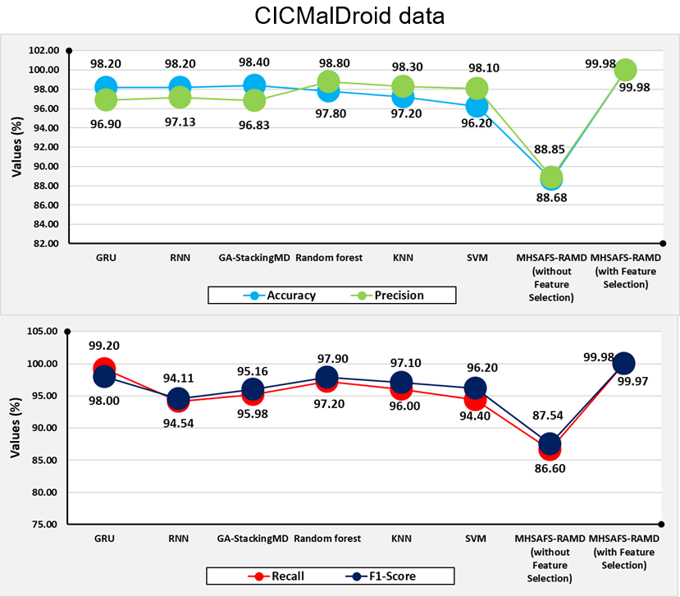
Fig. 9. Comparison of outcomes of the MHSAFS-RAMD method with various metrics
4.2. Results Analysis on AndroMD Dataset
Fig. 10 displays the confusion matrices of the MHSAFS-RAMD model under the Train/Test on AndroMD data without feature selection (FS). The outcomes denote that the MHSAFS-RAMD technique precisely recognizes each class.
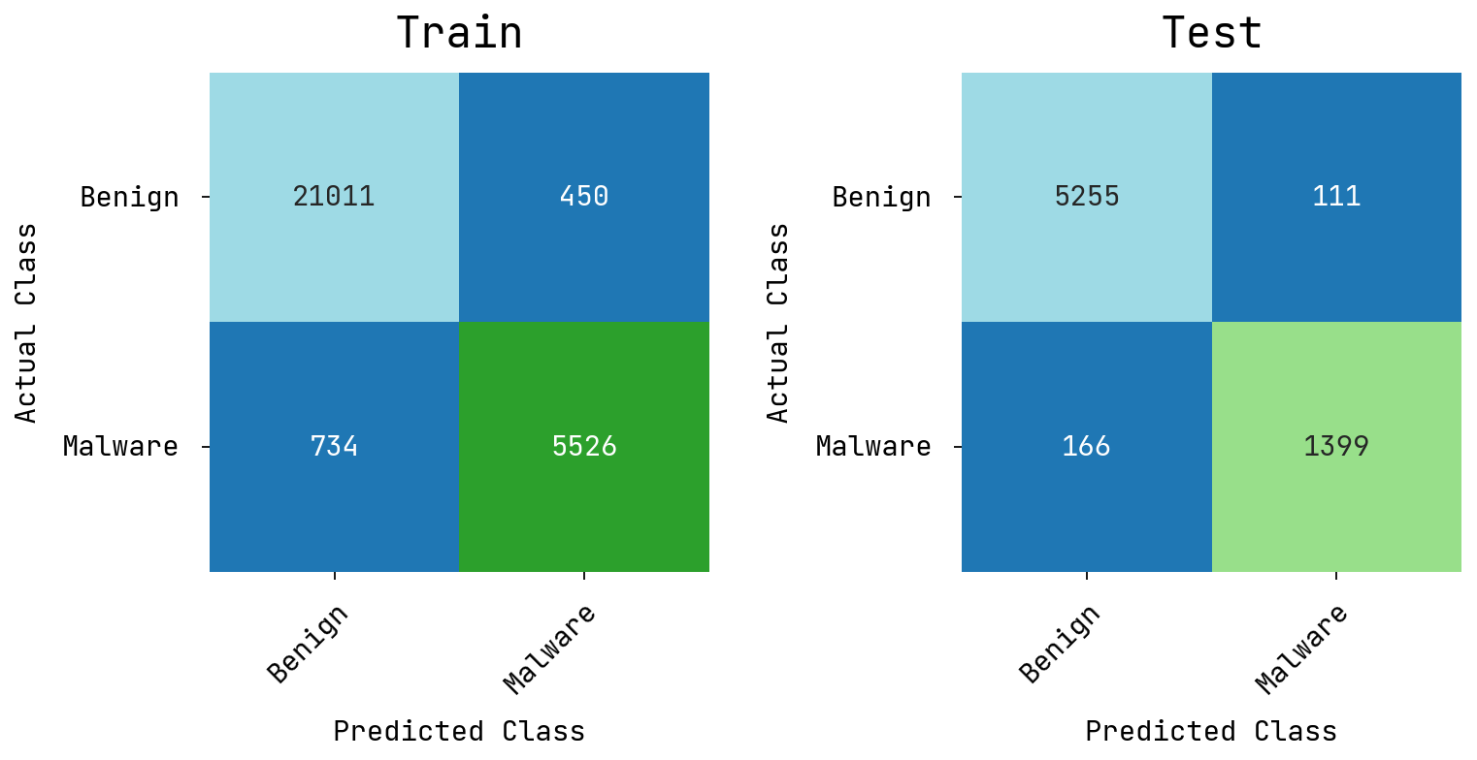
Fig. 10. Confusion matrices of the MHSAFS-RAMD method without FS under AndroMD data
Table 5 demonstrates the train and test results of MHSAFS-RAMD system under AndroMD data without FS under numerous measures. On training set, the proposed MHSAFS-RAMD technique attains average result with $accur_{y}$ of 95.73%, $preci_{n}$ of 94.55%, $recal_{l}$ of 93.09%, $F1_{score}$ of 93.79%, $ROC-AUC_{score}$ of 99.05%, MCC of 87.60%. Similarly, on testing set, the proposed MHSAFS-RAMD system accomplishes average result with $accur_{y}$ of 96.00%, $preci_{n}$ of 94.79%, $recal_{l}$ of 93.66%, $F1_{score}$ of 94.21%, and $ROC-AUC_{score}$ of 99.08%, MCC of 88.40%, respectively.
Table 5 Train/Test set results of the MHSAFS-RAMD approach on AndroMD data without FS
Metrics | Training Set | Testing Set
Accuracy | 95.73 | 96.00
Precision | 94.55 | 94.79
Recall | 93.09 | 93.66
F1-Score | 93.79 | 94.21
ROC AUC Score | 99.05 | 99.08
MCC | 87.60 | 88.40

Fig. 11 represents the number of features chosen by the proposed model before FS and after FS under AndroMD dataset. The figure indicate that the presented model has selected 120 features from the available 415 features. It implies that the presented model significantly reduced the feature subset and thereby resulted in enhanced classification performance.
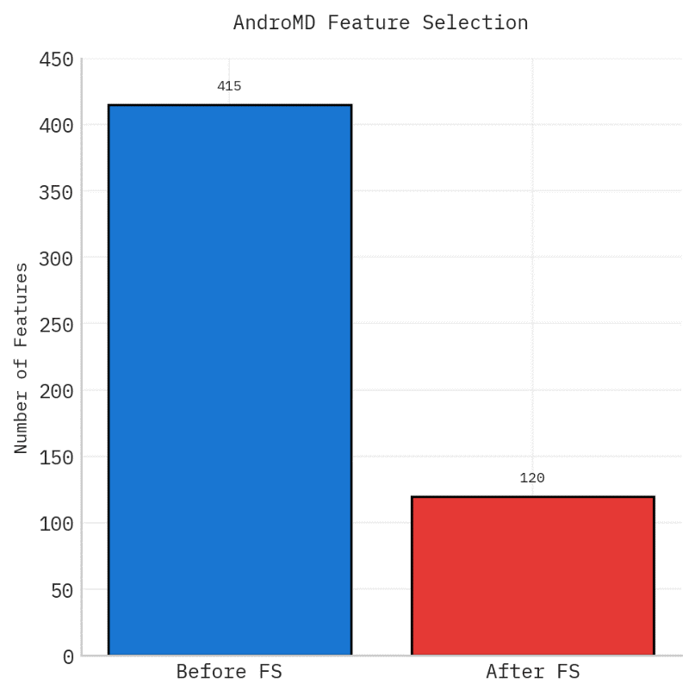
Fig. 11. Before FS and After FS under AndroMD data
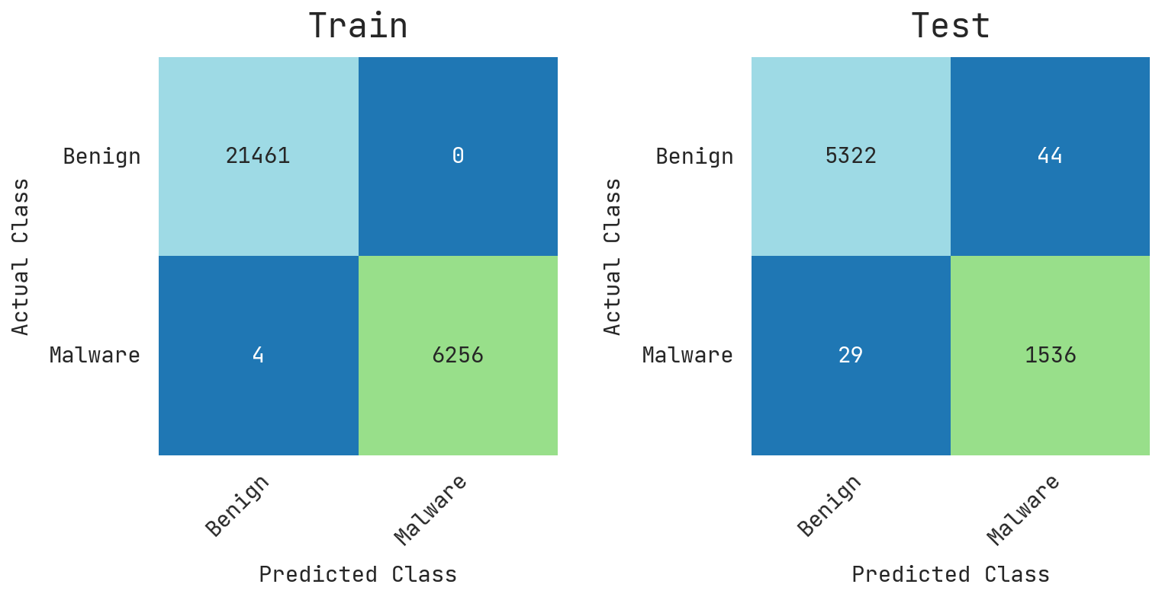
Fig. 12. Confusion matrices of the MHSAFS-RAMD method with FS under AndroMD data
Fig. 12 presents the confusion matrices generated by the MHSAFS-RAMD model on the Train/Test under CICMalDroid data with feature selection (FS). The outcomes denote that the MHSAFS-RAMD system proficiently recognizes all classes.
Table 6 presents the train and test results of MHSAFS-RAMD system on AndroMD data with FS under various measures. With training set, the proposed MHSAFS-RAMD model obtains average result with $accur_{y}$ of 99.99%, $preci_{n}$ of 99.99%, $recal_{l}$ of 99.97%, $F1_{score}$ of 99.98%, $ROC-AUC_{score}$ of 99.98%, and MCC of 99.96%. Likewise, at testing set, the proposed MHSAFS-RAMD model obtains average result with $accur_{y}$ of 98.95%, $preci_{n}$ of 98.34%, $recal_{l}$ of 98.66%, $F1_{score}$ of 98.50%, $ROC-AUC_{score}$ of 99.90%, and MCC of 97.00%, respectively.
Table 6 Train/Test set results of the MHSAFS-RAMD method on AndroMD data with FS
Metrics | Training Set | Testing Set
Accuracy | 99.99 | 98.95
Precision | 99.99 | 98.34
Recall | 99.97 | 98.66
F1-Score | 99.98 | 98.50
ROC-AUC Score | 99.98 | 99.90
MCC | 99.96 | 97.00

Fig. 13 shows the PR/ROC curves of MHSAFS-RAMD model on training and testing phases with AndroMD data. Figs. 13a-13c depicts the PR analysis of the MHSAFS-RAMD technique. The outcomes pointed out that the MHSAFS-RAMD model improves PR values. Further, it is noteworthy that the MHSAFS-RAMD model obtains maximal PR values on each class. Lastly, Figs. 13b-13d presents the ROC study of the MHSAFS-RAMD system. The figure explained that the MHSAFS-RAMD model improves ROC values. In addition, it is noteworthy that the MHSAFS-RAMD model attains superior ROC values on all classes.

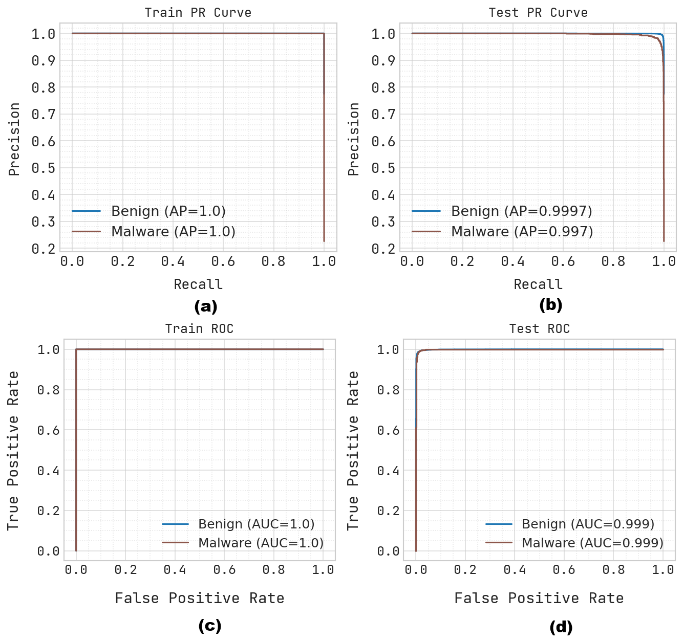
Fig. 13. PR/ROC curve of the MHSAFS-RAMD method with (a, c) Training and (b, d) Testing phases
The comparative study of the MHSAFS-RAMD system with existing models on the AndroMD dataset on different evaluation metrics is shown in Table 7 and Fig. 14. The simulation outcomes specify that the MHSAFS-RAMD model performed better compared to existing approaches. The outcomes pointed out that the Naïve Bayes, Embedded Call Graphs, and AE+DNN methodologies have shown the worst performance. In the meantime, Decision Tree, DNN, and RFC methodologies have attained closer results. Moreover, the MHSAFS-RAMD (without Feature Selection) technique has demonstrated reasonable performance with $acc{ur}_{y}$ of 96.00%, $pre{ci}_{n}$ of 94.79%, $rec{al}_{l}$ of 93.66%, and ${F1}_{score}$ of 94.21%, while the MHSAFS-RAMD (with Feature Selection) has attained maximum performance with $acc{ur}_{y}$ of 98.95%, $pre{ci}_{n}$ of 98.34%, $rec{al}_{l}$ of 98.66%, and ${F1}_{score}$ of 98.50%.

Table 7 Comparison study of the MHSAFS-RAMD method with existing systems
Models | $Acc{ur}_{y}$ | $Pre{ci}_{n}$ | $$Rec{al}_{l}$$ | $${F1}_{score}$$
Decision Tree | 96.60 | 96.20 | 97.30 | 96.60
Naïve Bayes | 93.90 | 94.30 | 93.50 | 93.90
DNN | 96.76 | 94.71 | 97.77 | 96.12
RFC | 96.20 | 94.28 | 95.26 | 95.87
Embedded Call Graphs | 94.60 | 97.26 | 93.03 | 96.41
AE+DNN | 95.80 | 96.56 | 97.20 | 96.03
MHSAFS-RAMD (without Feature Selection) | 96.00 | 94.79 | 93.66 | 94.21
MHSAFS-RAMD (with Feature Selection) | 98.95 | 98.34 | 98.66 | 98.50

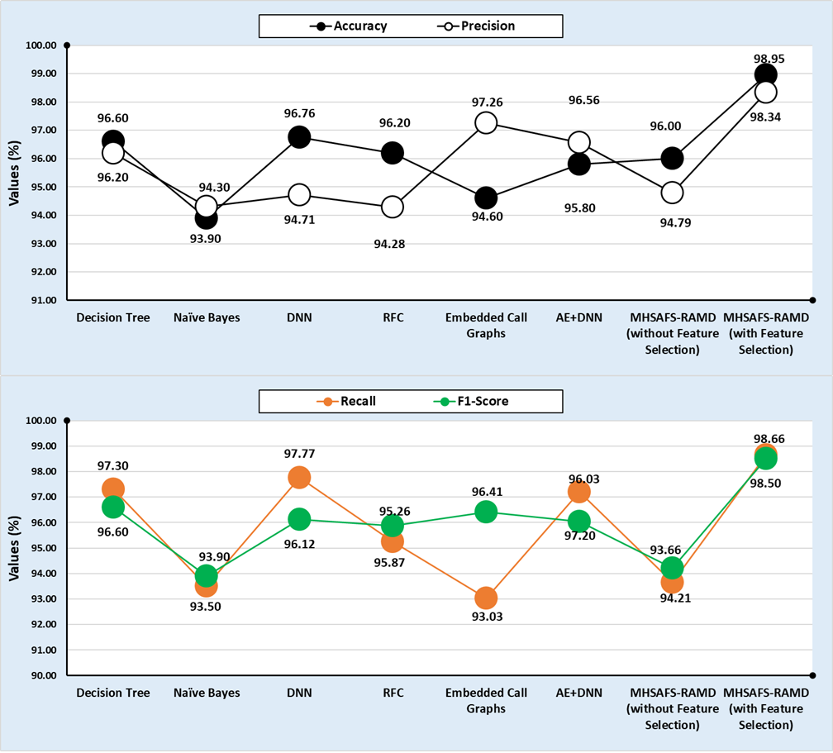
Fig. 14. Comparative analysis of the MHSAFS-RAMD method with several measures
The detailed results highlight that the proposed MHSAFS-RAMD method provides the most precise and effective outcomes among all techniques evaluated.
5. Conclusion
In this manuscript, the MHSAFS-RAMD model has been presented for identifying malicious Android applications by automatically learning discriminative feature interactions from high-dimensional static and dynamic attributes. The proposed model incorporates attention-based feature learning with XGBoost classification for addressing the challenges of high-dimensional feature spaces and redundant features in Android malware datasets. The MHSA network efficiently captured contextual relationships among static and dynamic features, allowing the selection of the most beneficial features for malware identification. By choosing relevant features through attention-based importance learning, the model minimized dimensionality while preserving discriminative information. The experimental assessment demonstrated that the proposed system accomplishes better detection performance compared to the baseline model trained on the complete feature space, with maximum accuracy of 99.98% and 99.99% on CICMalDroid 2020 and AndroMD datasets, respectively. The incorporation of feature selection and gradient boosting classification results in improved accuracy and reduced computational overhead. Moreover, the reduction of redundant and noisy features helped reduce overfitting and enhanced model stability across different datasets. Therefore, the MHSAFS-RAMD approach offers an effective solution for Android malware detection. In future, we plan to concentrate on improving Android malware detection by integrating real-time behavioral analysis and federated learning for enhanced privacy and scalability. The proposed model can be extended to manage zero-day attacks by the use of advanced anomaly detection and continual learning strategies. Moreover, explainable AI techniques can be incorporated to boost transparency and trust in security-critical applications.
Data Availability Statement: The data that support the findings of this study are openly available at https://www.unb.ca/cic/datasets/maldroid-2020.html and https://data.mendeley.com/datasets/pwyj5b3khp/1, reference number [21, 22].
References
- Kharnotia, S., Arora, B. and Kour, R., 2026. Feature-Driven Static Analysis for Learning-Based Android Malware Detection: A Review. ICT Express.
- Huang, H., Huang, W., Zhou, Y., Luo, W. and Wang, Y., 2025. FEdroid: a lightweight and interpretable machine learning-based android malware detection system. Cluster Computing, 28(4), p.224.
- Tyagi, T. and Gautam, M., 2024, July. Machine learning based malware detection in Android: A practical approach. In 2024 IEEE 3rd World Conference on Applied Intelligence and Computing (AIC) (pp. 1417-1424). IEEE.
- Jain, S., Goyal, H., Arora, A. and Kumar, D., 2026. EnFeSTDroid: Ensembled feature selection techniques based Android malware detection. Computers and Electrical Engineering, 129, p.110763.
- Yin, X., 2026. Research on Deep Learning-Based Android Malware Detection Systems. International Journal of Digital Crime and Forensics (IJDCF), 18(1), pp.1-15.
- Duarte, D.F. and Bortoli, A.A., 2026. Empirical Evaluation of SMOTE in Android Malware Detection with Machine Learning: Challenges and Performance in CICMalDroid 2020. arXiv preprint arXiv:2602.08744.
- Park, S., Lee, H., Kim, D., Moon, H.J., Cho, S., Hwang, Y., Han, H. and Suh, K., 2025. Enhancing the sustainability of machine learning-based malware detection techniques for android applications. IEEE Access.
- Taheri, R., Shojafar, M., Arabikhan, F. and Gegov, A., 2024. Unveiling vulnerabilities in deep learning-based malware detection: Differential privacy driven adversarial attacks. Computers & Security, 146, p.104035.
- Masari, M.S., Danladi, M.A., Onyinye, I.L. and Tohomdet, L.K., 2026. Android Malware Detection Using Machine Learning with SMOTE-Tomek Data Balancing. Journal of Computing Theories and Applications, 3(3), pp.302-313.
- Pathak, A., Barman, U. and Kumar, T.S., 2025. Machine learning approach to detect android malware using feature-selection based on feature importance score. Journal of Engineering Research, 13(2), pp.712-720.
- Alhogail, A. and Alharbi, R.A., 2025. Effective ml-based android malware detection and categorization. Electronics, 14(8), p.1486.
- Sharma, M. and Kaul, A., 2024. A review of detecting malware in android devices based on machine learning techniques. Expert Systems, 41(1), p.e13482
- Kirubavathi, G., Padma Mayuri, B., Pranathasree, S., Alagappan, R., Ajayan, A., Ismael, W.M. and Rehman, A.U., 2026. Ensemble machine learning for proactive android ransomware detection using network traffic. Scientific Reports.
- Poornima, S. and Mahalakshmi, R., 2024. Automated malware detection using machine learning and deep learning approaches for android applications. Measurement: Sensors, 32, p.100955.
- Musa, H.O. and Younis, M.T., 2026. Effective Android Malware Detection Using CNN and LSTM Model with GWO-Based Feature Selection. Babylonian Journal of Machine Learning, 2026, pp.1-22.
- Mudunuru, K. and Rani, M.U., 2026. A hybrid deep-handcrafted feature fusion framework for image based android malware detection. Future Technology, 5(2), pp.129-137.
- Nethala, S., Chopra, P., Kamaluddin, K., Alam, S., Alharbi, S. and Alsaffar, M., 2025. A deep learning-based ensemble framework for robust android malware detection. Ieee Access, 13, pp.46673-46696.
- Vijaya, B.J., Achari, P.K., Ganesh, D., Kumar, P.V.S. and Rakesh, K., 2026. A Robust Android Malware Detection Framework Based on Intelligent Classification Models. International Journal of Human Computations and Intelligence, 5(1), pp.721-733.
- Nelson, J., Pavlidis, M., Fish, A., Kapetanakis, S. and Polatidis, N., 2025. ChatGPT-driven machine learning code generation for android malware detection. The Computer Journal, 68(4), pp.331-345.
- Wasif, M.S., Miah, M.P., Hossain, M.S., Alenazi, M.J. and Atiquzzaman, M., 2025. CNN-ViT synergy: An efficient Android malware detection approach through deep learning. Computers and Electrical Engineering, 123, p.110039.
- https://www.unb.ca/cic/datasets/maldroid-2020.html
- https://data.mendeley.com/datasets/pwyj5b3khp/1
- Talukder, M.A., Khalid, M. and Sultana, N., 2025. A hybrid machine learning model for intrusion detection in wireless sensor networks leveraging data balancing and dimensionality reduction. Scientific reports, 15(1), p.4617.
- Fu, X., Wang, M., Zhang, D., Chen, F., Peng, X., Wang, L. and Tan, S.K., 2025. An XGBoost-SHAP framework for identifying key drivers of urban flooding and developing targeted mitigation strategies. Ecological Indicators, 175, p.113579.
- Ru, Y., An, G., Wei, Z. and Chen, H., 2024. Epilepsy detection based on multi-head self-attention mechanism. PLoS One, 19(6), p.e0305166.
- Elayan, O.N. and Mustafa, A.M., 2021. Android malware detection using deep learning. Procedia Computer Science, 184, pp.847-852.
- Alhogail, A. and Alharbi, R.A., 2025. Effective ml-based android malware detection and categorization. Electronics, 14(8), p.1486.
- Anđelić, N. and Baressi Šegota, S., 2024. Achieving High Accuracy in Android Malware Detection through Genetic Programming Symbolic Classifier. Computers, 13(8), p.197.

